www.weswhiddonscholarship.com
Helping Clay County Student-Athletes Go To College

The Wes Whiddon Athletic Scholarship was established by the OPJH Athletic Department in order to help local kids go to college. The Foundation awards scholarships in the amount of $1,042. The scholarship is available to any graduating Clay County student-athlete who played sports at the junior high or high school level while attending a Clay County public school. Largely due to community support, we have been fortunate enough to award 96 scholarships to Clay County graduates in honor of Wesley Whiddon, totaling $100,032. Playing college football and receiving a college education was Wesley’s dream. Our goal is to help make Wesley’s dream of a college education a reality for as many Clay County student-athletes as possible.
Potential recipients should submit this application form accompanied with an essay entitled “How I Make a Difference”. The most important factor our scholarship’s committee will consider when selecting recipients is the difference that applicants have and will make in the world. Wesley Whiddon’s life was cut far too short… however, he made a positive impact on the world in his limited time. If an applicant has already been accepted to the college they plan to attend, the applicant should also submit a copy of their acceptance letter.
Applicants are also welcome to include any additional information they would like our selection committee to consider. There are no minimum or maximum length requirements for the essay. We simply want to know how you make a difference in the world. Applications and Essays are due no later than April 10, 2024.
“On behalf of the Whiddon family, I would like to wish you and every future applicant Good Luck with your application and in life as you transition beyond High School. I would also like to thank anyone reading this… in doing so, you are helping keep Wesley’s memory alive and ensuring that Wesley continues to make a positive impact on the world that we live in.
Over twenty years ago, I received a similar scholarship. Coach Fulcher, you made a difference in my life way back then. That money bought an awful lot of ramen noodles and a few books my freshman year of college. Attempting to repay your kindness by being a part of this scholarship foundation has been one of the most rewarding endeavors of my life. As you all move forward in life, please understand that no one gets anywhere alone.”
- Robert Worley
Founder, Wes Whiddon Scholarship

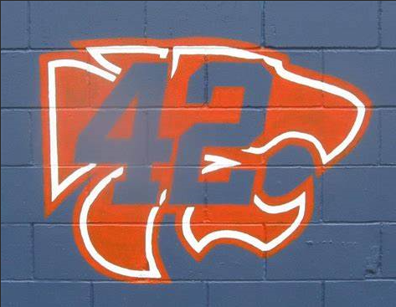

YOUR LIFE IS YOUR MESSAGE
TO THE WORLD,
MAKE IT COUNT!
2024 Wes Whiddon Scholarship Application Due by April 10, 2024
2020 Cameron Broughton, OPHS
Joseph Justino, MHS
Peyton LaBelle, FIHS
Zach Little, FIHS
Anthony Paterra, FIHS
Grace Schriver, OLHS
Morgan Silvis, CHS

Name: ______________________ Home Address:____________________________________
City: _________________________ Zip Code: _____________Telephone: (____)____________
Clay County Junior High and/or High School Attended: ________________________________
High School Cumulative GPA: _________ Sports Played While Attending Clay County School:

College you plan to attend (if known at this time):

Have you already been accepted? Y / N
If yes, please provide copy of acceptance letter.
Please attach this application to your essay entitled
“How I Make a Difference” and submit to:Michelle.solomon@myoneclay.net or mail
Wes Whiddon Athletic Scholarship / WEC
Attn: Michelle Solomon / Scholarship Committee
420 Edson Drive Orange Park, FL 32073

